<https://www.documenta14.de/de/artists/13557/cecilia-vicuna>

Cecilia Vicuña

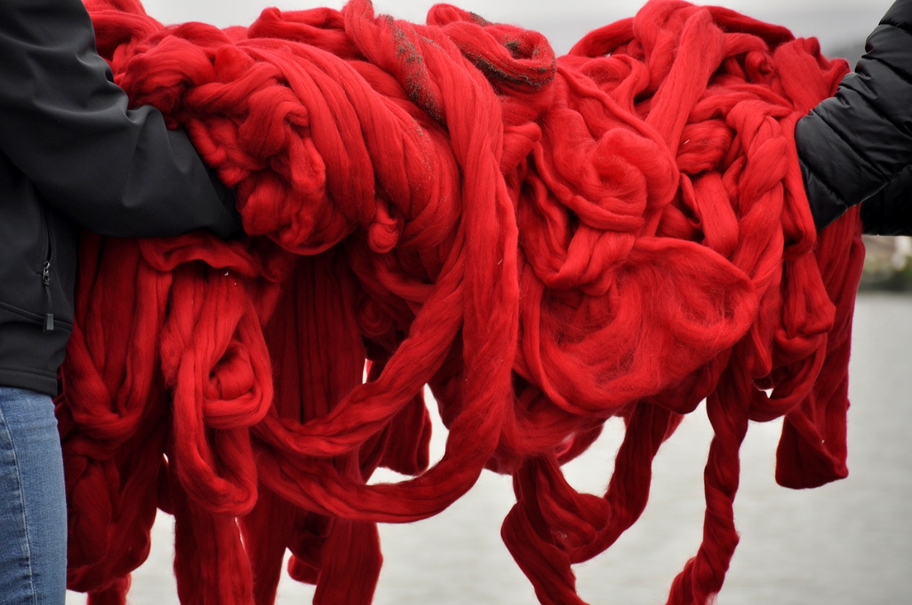

Cecilia Vicuña, *Quipu Mapocho* (2016), verschiedene Materialien, u. a. ungesponnene Wolle, Zweige, Schnur, ca. 2 × 1,5 × 1,5 m, Performance, Llolleo, Chile, courtesy Cecilia Vicuña und Englund & Co. Gallery, London

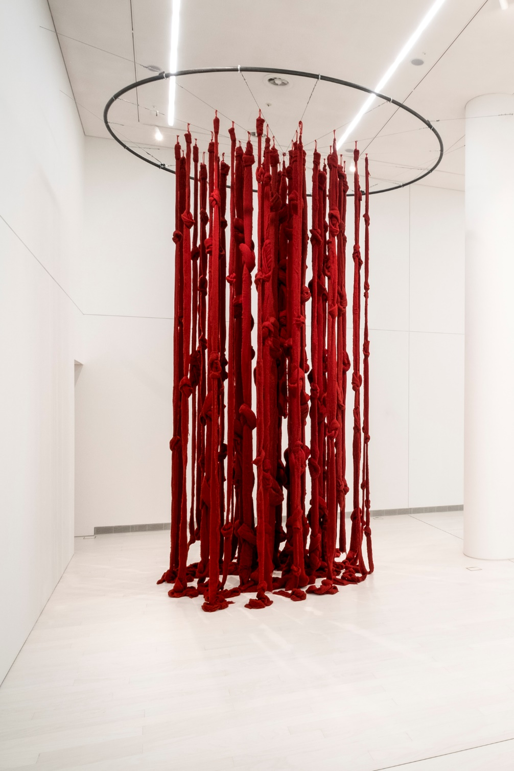

Cecilia Vicuña, *Quipu Womb (The Story of the Red Thread, Athens),*2017, gefärbte Wolle, Installationsansicht, EMST – Nationales Museum für Zeitgenössische Kunst, Athen, documenta 14, Foto: Mathias Völzke

**Werke**

Cecilia Vicuña  
(geb. 1948, Santiago de Chile)

*Quipu Womb (The Story of the Red Thread, Athens)* (2017)  
Gefärbte Wolle  
Ca. 6 × 8 m  
[EMST – Nationales Museum für Zeitgenössische Kunst](https://www.documenta14.de/de/venues/14860/emst-nationales-museum-fuer-zeitgenoessische-kunst), Athen  
  
*A Ritual Performance by the Sea* (2017)  
[Küste](https://www.documenta14.de/de/venues/15974/kueste), Athen

*Karl Marx* (1972)  
Öl auf Leinwand  
92,1 × 71,7 cm

*Lenin* (1972)  
Öl auf Leinwand  
56,5 × 51,4 cm

*Angel de la Menstruación* (Menstruationsengel, 1973)  
Öl auf Leinwand   
57,8 × 48,3 cm  
Sammlung Catherine Petitgas, London

*Fidel y Allende* (1972)   
Öl auf Leinwand (Ausstellungskopie)   
72 × 59 cm

*Muerte de Allende* (Tod von Allende, 1973)  
Öl auf Leinwand  
57,1 × 40 cm

*Violeta Parra* (1973)  
Öl auf Leinwand (Ausstellungskopie)   
57,8 × 48,3 cm

*Gabriela Mistral* (1986)  
Öl auf Leinwand   
61 × 49 cm

*Maria Sabina* (1986)  
Öl auf Leinwand  
59,7 × 49,5 cm

Alle Werke [Neue Galerie](https://www.documenta14.de/de/venues/21726/neue-galerie), Kassel

*Quipu Gut* (2017)  
Gefärbte Wolle  
Maße variabel  
[documenta Halle](https://www.documenta14.de/de/venues/21711/documenta-halle), Kassel

*Ritual Performance*(2017)  
Performance  
[documenta Halle](https://www.documenta14.de/de/venues/21711/documenta-halle), Kassel

In ihrer nordamerikanischen Wahlheimat – die Künstlerin lebt seit den 1980er Jahren in New York – ist Cecilia Vicuña in erster Linie für ihr dichterisches Werk bekannt. Dennoch ist sie der Berufung ihrer Jugendzeit treu geblieben und arbeitet seit mehr als vierzig Jahren als bildende Künstlerin in unterschiedlichsten Genres. Ihre ortsspezifischen Projekte sind Ausdruck ihrer Gabe, räumliche Gedichte zu komponieren, empfindsame, gefühlsbetonte Lyrik in drei Dimensionen. Vicuña bezeichnet diese speziellen Arbeiten als „quipoems“ – eine Verschmelzung von „poem“ (englisch für „Gedicht“) und „Quipu“. Letzteres wird in einem Online-Wörterbuch wie folgt definiert: „Aus einer Schnur bestehende Vorrichtung, an der mit Knoten versehene Fäden unterschiedlicher Farbe befestigt sind; diente im alten Peru zum Aufzeichnen von Ereignissen, zur Buchführung etc.“ Eine präkolumbische Art des Schreibens also, Frucht einer literarischen Tradition, der die Welt Dichtergrößen wie Gabriela Mistral, Pablo Neruda und Nicanor Parra verdankt. Vicuña, 1948 in Santiago de Chile geboren, ist sich der Bedeutung indigener Geschichte als Fundament für die lateinamerikanische Kultur des 20. Jahrhunderts in höchstem Maße bewusst.

Ihr aktuelles „quipoem“ in Athen in Form einer immersiven „weichen Skulptur“ in Übergröße besteht aus riesigen Fäden ungesponnener Wolle. Letztere wurde von einem lokalen Lieferanten bezogen und auffallend purpurrot gefärbt – zu Ehren einer synkretistischen religiösen Tradition, die durch die Nabelschnur menstrueller Symbolik die Muttergottheiten der Andenregion mit den maritimen Mythologien des alten Griechenland verknüpft.

Vicuñas frühe figurative Gemälde, entstanden zu Beginn der 70er Jahre, stellen die Porträts von Dichterinnen (unter anderen Mistral) einer Phalanx aus männlichen Politikheroen (unter anderen Karl Marx, Lenin, Fidel Castro und Chiles Salvador Allende) gegenüber. Deren unbeugsame Männlichkeit wird durch den für die Künstlerin typischen Pop-Stil auf amüsante Weise unterlaufen. Beispiele sind die heiligenscheinähnliche Blumengirlande rund um Marx’ Kopf oder die merkwürdige, an Genitalien gemahnende Symbolik in der surrealen Landschaft hinter Lenin. Diese Porträts, 1972 gemalt, wirken heute wie wehmütige Erinnerungen an einen vorzeitig beendeten utopischen Augenblick: Im Jahr darauf setzte ein von der CIA unterstützter und von Pinochet angeführter Militärputsch einen blutigen Schlussstrich unter Allendes sozialistisches Experiment. Diese Ereignisse zwangen auch Cecilia Vicuña in ein Exil – erst nach London und Kolumbien, dann nach New York –, aus dem die Künstlerin nie mehr wirklich heimgekehrt ist.

— Dieter Roelstraete

Gepostet in [Öffentliche Ausstellung](https://www.documenta14.de/de/public-exhibition/#artists)  
Auszug aus dem [*documenta 14: Daybo*](https://www.documenta14.de/de/publications/15730/documenta-14-daybook)

https://www.documenta14.de/de/calendar/19155/open-day

# Open day mit Cecilia Vicuña

MAI

2

Gespräch

17 Uhr

[Hochschule der Bildenden Künste Athen (ASFA) – Pireos-Straße („Nikos-Kessanlis“-Ausstellungshalle)](https://www.documenta14.de/de/venues/15226/hochschule-der-bildenden-kuenste-athen-asfa-pireos-strasse-nikos-kessanlis-ausstellungshalle-), Pireos 256, Athen

Zum [iCal](https://www.documenta14.de/de/calendar/19155/open-day.ics) oder [Google Calendar](https://www.documenta14.de/de/calendar/19155/open-day.google) hinfügen

**Ein Gespräch in der von Aristide Antonas gestalteten "Alten Bibliothek" als einem performativen Raum der Bildung und Begegnung.** Cecilia Vicuña befasst sich mit alten und ursprünglichen Ritualen als mögliches Modell für die Zukunft und für die kollektive Produktion.

https://www.documenta14.de/de/calendar/16501/beach-ritual

# Beach ritual von Cecilia Vicuña

APR

10

Performance

18–20 Uhr

[Küste](https://www.documenta14.de/de/venues/15974/kueste), Athen

Zum [iCal](https://www.documenta14.de/de/calendar/16501/beach-ritual.ics) oder [Google Calendar](https://www.documenta14.de/de/calendar/16501/beach-ritual.google) hinfügen

Diese Performance ist integraler Bestandteil von Cecilia Vicuñas Beitrag zur documenta 14 – ein Opfer am Meeresufer, wobei sie dieselbe griechische Wolle benutzt, die sie schon bei der Herstellung ihrer „quipu“-Installation am EMST– Nationales Museum für Zeigenössische Kunst verwendet hat.

(South as a State of Mind Issue #8, documenta 14, #3)

https://www.documenta14.de/de/south/904_language_is_migrant

Language Is Migrant

Von Cecilia Vicuña

Language is migrant. Words move from language to language, from culture to culture, from mouth to mouth. Our bodies are migrants; cells and bacteria are migrants too. Even galaxies migrate.

What is then this talk against migrants? It can only be talk against ourselves, against life itself.

Twenty years ago, I opened up the word “migrant,” seeing in it a dangerous mix of Latin and Germanic roots. I imagined “migrant” was probably composed of *mei*, Latin for “to change or move,” and *gra*, “heart” from the Germanic *kerd*. Thus, “migrant” became “changed heart,”

a heart in pain,   
changing the heart of the earth.

The word “immigrant” says, “grant me life.”

“Grant” means “to allow, to have,” and is related to an ancient Proto-Indo-European root: *dhe*, the mother of “deed” and “law.” So too, *sacerdos,* performer of sacred rites.

What is the rite performed by millions of people displaced and seeking safe haven around the world? Letting us see our own indifference, our complicity in the ongoing wars?

Is their pain powerful enough to allow us to change our hearts? To see our part in it?

I “wounder,” said Margarita, my immigrant friend, mixing up wondering and wounding, a perfect embodiment of our true condition!

Vicente Huidobro said, “Open your mouth to receive the host of the wounded word.”

The wound is an eye. Can we look into its eyes?

my specialty is not feeling, just  
looking, so I say:  
(the word is a hard look.)  
—Rosario Castellanos

I don’t see with my eyes: words  
are my eyes.   
—Octavio Paz

In l980, I was in exile in Bogotá, where I was working on my “Palabrarmas” project, a way of opening words to see what *they* have to say. My early life as a poet was guided by a line from Novalis: “Poetry is the original religion of mankind.” Living in the violent city of Bogotá, I wanted to see if anybody shared this view, so I set out with a camera and a team of volunteers to interview people in the street. I asked everybody I met, “What is Poetry to you?” and I got great answers from beggars, prostitutes, and policemen alike. But the best was, “Que prosiga,” “That it may go on”—how can I translate the subjunctive, the most beautiful *tiempo verbal* (time inside the verb) of the Spanish language? “Subjunctive” means “next to” but under the power of the unknown. It is a future potential subjected to unforeseen conditions, and that matches exactly the quantum definition of emergent properties.

If you google the subjunctive you will find it described as a “mood,” as if a verbal tense could feel: “The subjunctive mood is the verb form used to express a wish, a suggestion, a command, or a condition that is contrary to fact.” Or “the ‘present’ subjunctive is the bare form of a verb (that is, a verb with no ending).”

I loved that! A never-ending image of a naked verb! The man who passed by as a shadow in my film saying “Que prosiga” was on camera only for a second, yet he expressed in two words the utter precision of Indigenous oral culture.

People watching the film today can’t believe it was not scripted, because in thirty-six years we seem to have forgotten the art of complex conversation. In the film people in the street improvise responses on the spot, displaying an awareness of language that seems to be missing today. I wounder, how did it change? And my heart says it must be fear, the ocean of lies we live in, under a continuous stream of doublespeak by the violent powers that rule us. Living under dictatorship, the first thing that disappears is playful speech, the fun and freedom of saying what you really think. Complex public conversation goes extinct, and along with it, the many species we are causing to disappear as we speak.

The word “species” comes from the Latin *speciēs*, “a seeing.” Maybe we are losing species and languages, our joy, because we don’t wish to see what we are doing.

Not seeing the seeing in words, we numb our senses.

I hear a “low continuous humming sound” of “unmanned aerial vehicles,” the drones we send out into the world carrying our killing thoughts.

Drones are the ultimate expression of our disconnect with words, our ability to speak without feeling the effect or consequences of our words.

“Words are acts,” said Paz.

Our words are becoming drones, flying robots. Are we becoming desensitized by not feeling them as acts? I am thinking not just of the victims but also of the perpetrators, the drone operators. Tonje Hessen Schei, director of the film *Drone*, speaks of how children are being trained to kill by video games: “War is made to look fun, killing is made to look cool. ... I think this ‘militainment’ has a huge cost,” not just for the young soldiers who operate them but for society as a whole. Her trailer opens with these words by a former aide to Colin Powell in the Bush/Cheney administration:

OUR POTENTIAL COLLECTIVE FUTURE. WATCH IT AND WEEP FOR US. OR WATCH IT AND DETERMINE TO CHANGE THAT FUTURE   
—Lawrence Wilkerson, Colonel U.S. Army (retired)

In *Astro Noise*, the exhibitionby Laura Poitras at the Whitney Museum of American Art, the language of surveillance migrates into poetry and art. We lie in a collective bed watching the night sky crisscrossed by drones. The search for matching patterns, the algorithms used to liquidate humanity with drones, is turned around to reveal the workings of the system. And, we are being surveyed as we survey the show! A new kind of visual poetry connecting our bodies to the real fight for the soul of this Earth emerges, and we come out woundering: Are we going to dehumanize ourselves to the point where Earth itself will dream our end?

The fight is on everywhere, and this may be the only beauty of our times. The Quechua speakers of Peru say, “beauty is the struggle.”

Maybe darkness will become the source of light. (Life regenerates in the dark.)

I see the poet/translator as the person who goes into the dark, seeking the “other” in him/herself, what we don’t wish to see, as if this act could reveal what the world keeps hidden.

Eduardo Kohn, in his book *How Forests Think: Toward an Anthropology Beyond the Human* notes the creation of a new verb by the Quichua speakers of Ecuador: *riparana* means “darse cuenta,” “to realize or to be aware.” The verb is a Quichuan transfiguration of the Spanish *reparar*, “to observe, sense, and repair.” As if awareness itself, the simple act of observing, had the power to heal.

I see the invention of such verbs as true poetry, as a possible path or a way out of the destruction we are causing.

When I am asked about the role of the poet in our times, I only question: Are we a “listening post,” composing an impossible “survival guide,” as Paul Chan has said? Or are we going silent in the face of our own destruction?

Subcomandante Marcos, the Zapatista guerrilla, transcribes the words of El Viejo Antonio, an Indian sage: “The gods went looking for silence to reorient themselves, but found it nowhere.” That nowhere is our place now, that’s why we need to translate language into itself so that IT sees our awareness.

Language is the translator. Could it translate us to a place within where we cease to tolerate injustice and the destruction of life?

Life is language. “When we speak, life speaks,” says the Kaushitaki Upanishad.

Awareness creates itself looking at itself.

It is transient and eternal at the same time.

*Todo migra*. Let’s migrate to the “wounderment” of our lives, to poetry itself.

https://www.hessenschau.de/documenta360/#pano=581

